TASK 5.1.2 - LL.FESTIVAL

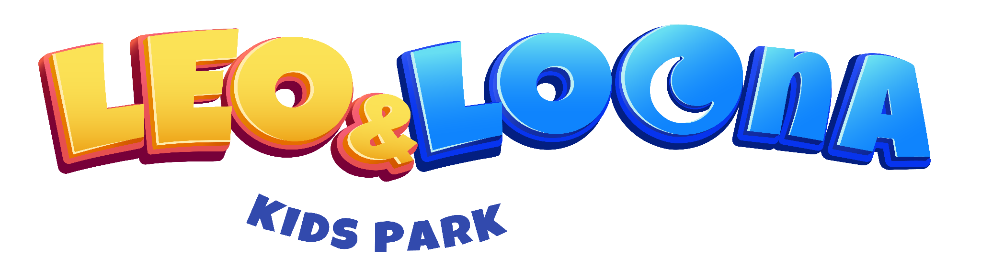

Parent & Guardian Release and Waiver of Liability

Please read this Release & Waiver Carefully before agreeing to it, You are giving up Legal Rights

1. Compliance with Park Rules and Regulations

All visitors must follow the instructions of park staff at all times.

Use equipment according to your skill level. Do not attempt activities beyond your capabilities.

Remove all items from pockets and avoid wearing glasses, jewelry, scarves, and other loose articles that may cause injury or damage equipment.

Long-haired guests should tie up their hair to avoid any accidents.

Rough play, climbing on nets or fences, and littering on equipment are strictly prohibited.

Visitors are required to adhere to the rules and instructions outlined in written form located in close proximity to each attraction. By entering, they acknowledge their commitment to thoroughly read and comply with these guidelines.

2. Supervision and Safety

Children must be supervised by an adult at all times.

Guests must adhere to height, weight and age restrictions for specific attractions.

I affirm as a parent/guardian that neither I nor my child will participate under the influence of drugs or alcohol, ensuring a safe engagement in the Leo and Loona and Hello Park activities.

3. Medical Release

It is advisable to consult a doctor or physician before undertaking any physical activity.

I confirm the absence of medical conditions or incapacity for both myself and dependents.

I, along with my dependents, confirm that we do not have any heart conditions, epilepsy, allergies, skeletal or spinal issues, a history of sports injuries, or any other medical condition that may pose a risk during activities or services. Similarly, guests with physical impairments, injuries, heart conditions, respiratory problems, or pregnant women are advised to refrain from participating in specific activities for their safety.

I also agree that I am responsible for any and all medical costs, including, but not limited to ambulance, hospital, pharmacy, physiotherapy, psychological, rehabilitation.

4. Personal Belongings

Leo and Loona and Hello Park is not responsible for lost, stolen, or damaged personal items. Please secure your belongings.

5. Acceptance of Risks

By entering the park, you acknowledge the inherent risks associated with amusement park activities and agree to assume all risks for yourself and any minors under your care.

6. Liability Waiver

You agree to release Leo and Loona, Hello Park, their employees, agents, and affiliates from any claims, liabilities, or damages arising from your visit.

7. Emergency Situations

In case of an emergency, park staff are authorized to provide necessary first aid and seek medical attention at your expense.

8. Personal Data and Privacy

By entering the park, you consent to the collection and use of your personal data in accordance with our privacy policy.

We may utilize your personal data for commercial purposes, but will not disclose it to third parties. By providing your personal data, you agree to its use, with the assurance that it will not be shared externally.

9. Acknowledgment and Agreement

By signing this waiver, you acknowledge that you have read, understood, and agreed to all the terms and conditions stated above.

Valid for: 9999 days

Minimum age to sign waiver: 18 years old